Module Name: selenium testing
Test case ID:TC_01
Webpage URL:www.selenium.com

Scenario ID : 1a

Scenario: text box
Test steps:
(1)open selenium website
(2)click text box

Screenshots:

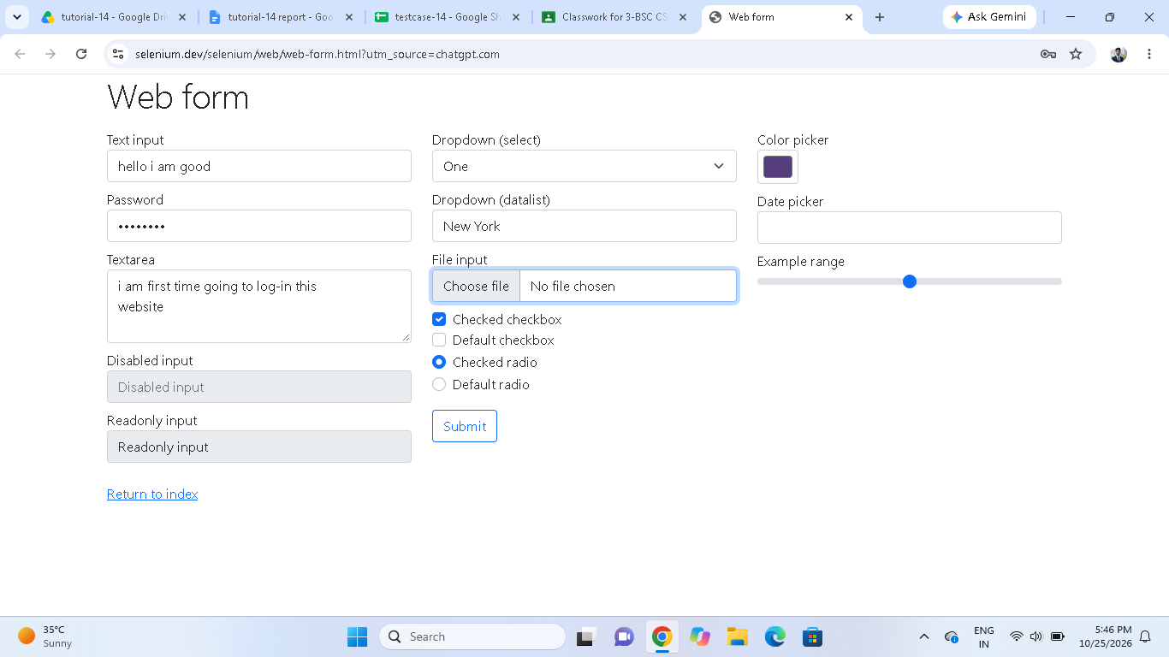

Scenario ID : 1b

Scenario: password
Test steps:

(1)open selenium website
(2)click password

Screenshots:

Scenario ID : 1c
Scenario: text area
Test steps:
(1)open selenium website
(2)click text area

Screenshots:
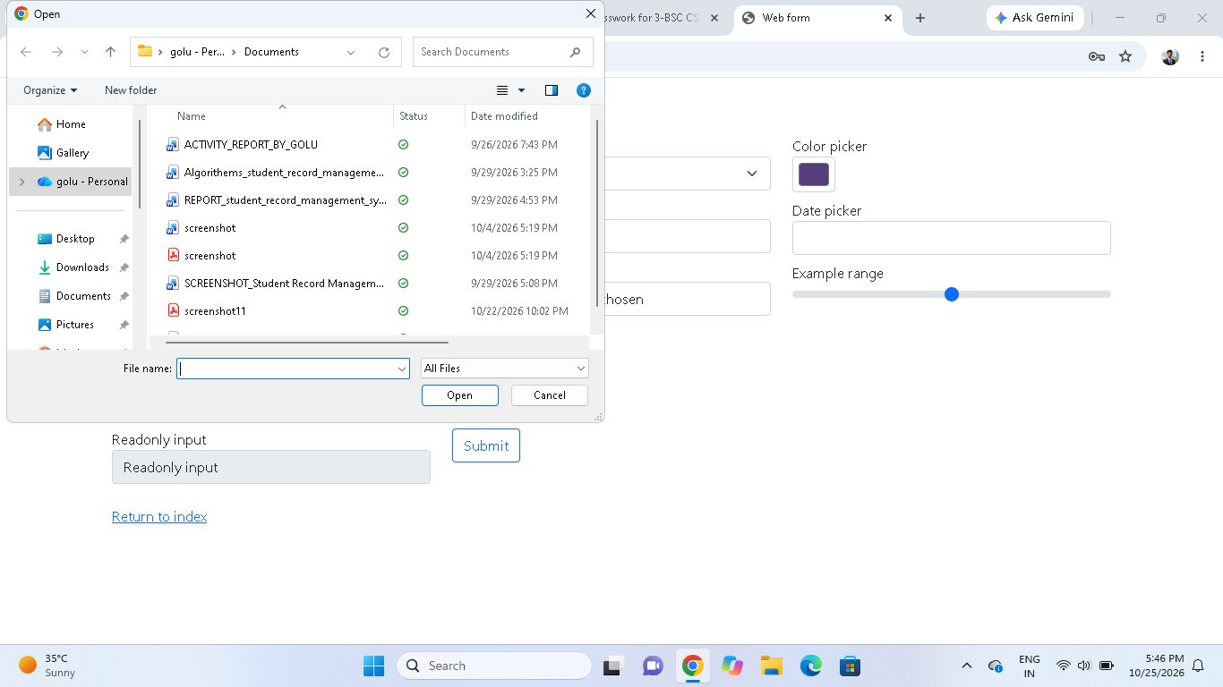

Scenario ID : 1d
Scenario: dropdown
Test steps:

(1)open selenium website
(2)click dropdown

Screenshots:

Scenario ID : 1e
Scenario: check box
Test steps:

(1)open selenium website
(2)click check box

Screenshots:

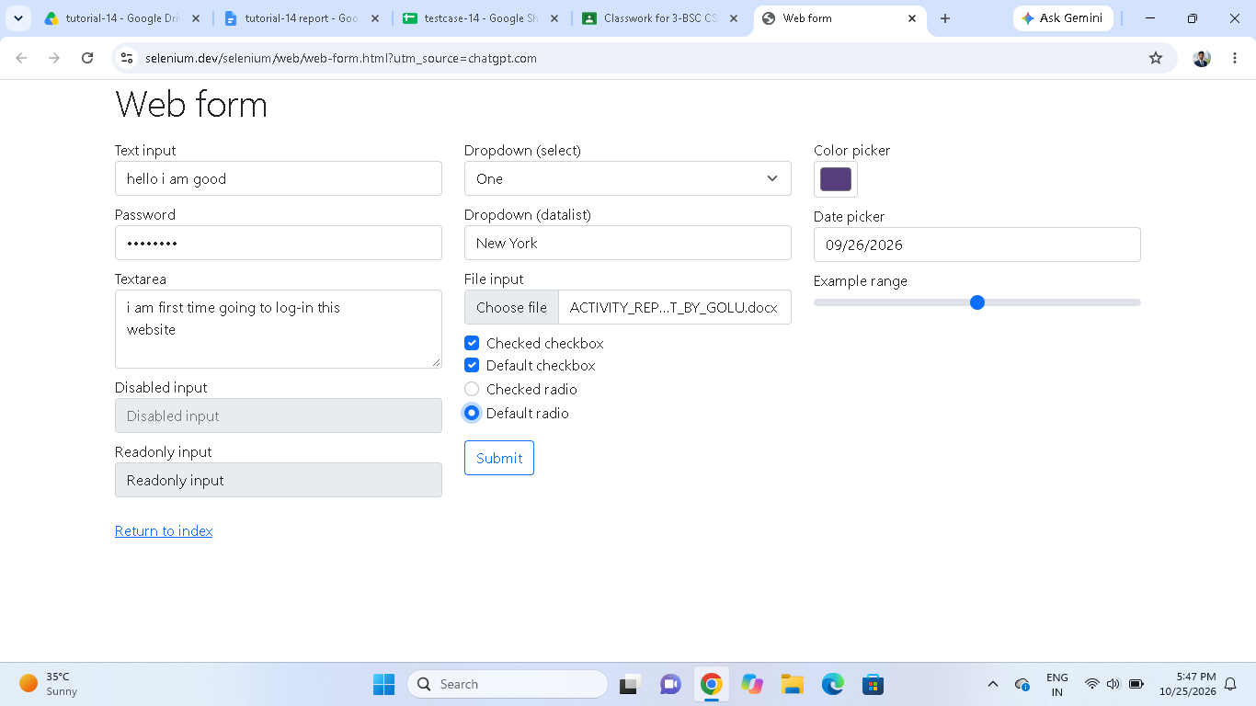

Scenario ID : 2a
Scenario:radio button
Test steps:
(1)open selenium website
(2)click on radio button

Screenshots:

Scenario ID : 2b
Scenario:submit
Test steps:
(1)open selenium website
(2)click on submit button

Screenshots:

